**ASSIGNMENT-17.5:**

**QUESTION:**

Write a map reduce program to design a custom counter to count number of people are affected with 'PULMONARY' disease and 'BRONCHITIS & ASTHMA' in the state 'CA'.

**Driver Class:**

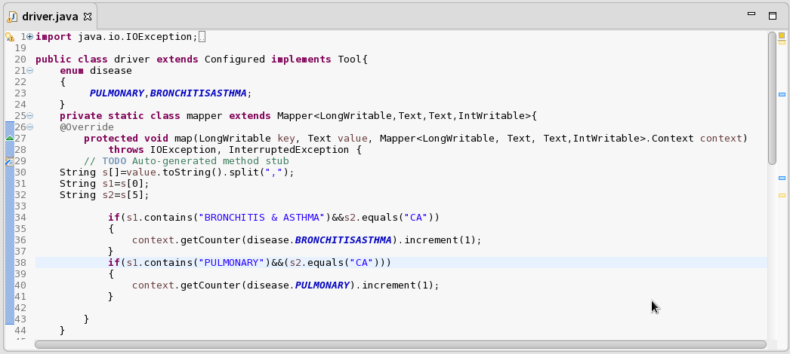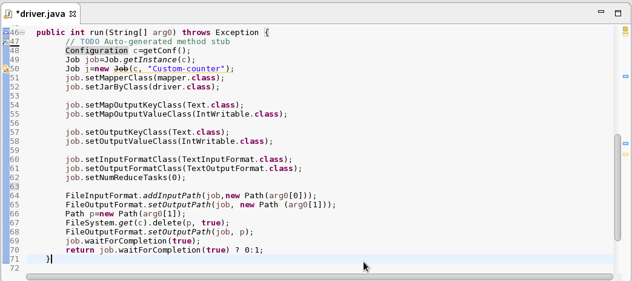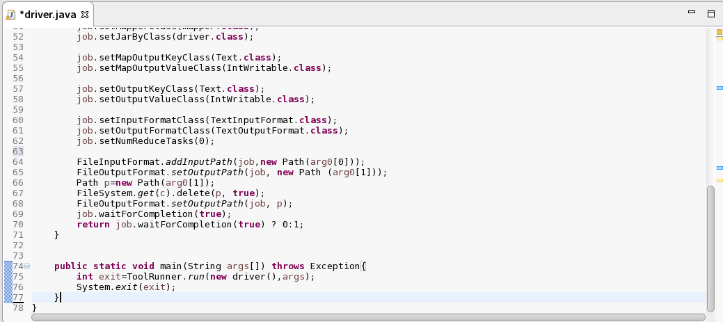

**Output:**

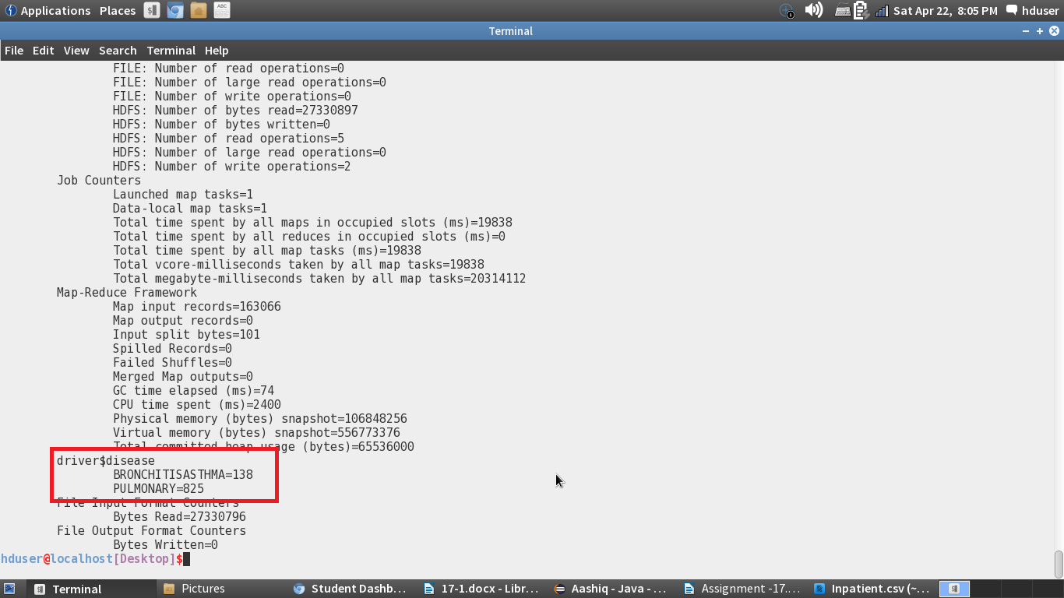

Job History Server Web-UI:

